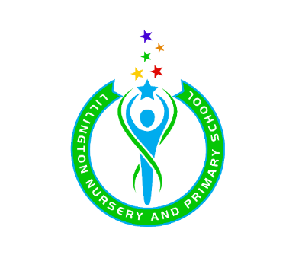
Spanish Skills and Progression – EYFS and KS1

Spanish is taught in Nursery through a visitor singing songs

Skills | Reception | Year 1 | Year 2
Listening | Enjoy listening to short stories | Listen to stories and explore the effects of repeated language | Listen and show understanding of key words or phrases with appropriate actions  Listen to stories
Pronunciation | Have fun trying to say words in a Spanish accent | Have fun trying to say words in a Spanish accent | Say a few familiar words with accurate pronunciation
Speaking | Copt and say some familiar words | Say some familiar words and phrases in front of the class | Perform a short role play with a partner
Reading | Recognise a few familiar words | Recognise some familiar words | Recognise several familiar words
Patterns and sounds | Join in with singing a song to a familiar tune with actions | Join in with singing a song to a familiar tune with actions | Join in with singing a song to a familiar tune with actions
Vocabulary | Memorise some vocabulary through songs and games | Memorise some vocabulary through songs and games | Use given strategies to memorise vocabulary

