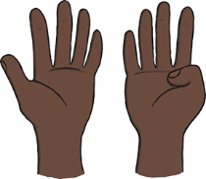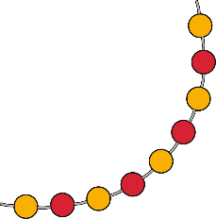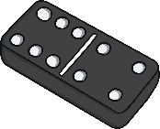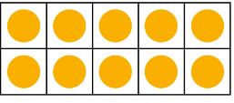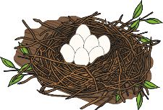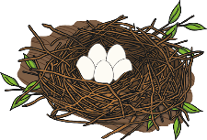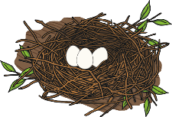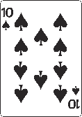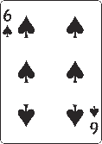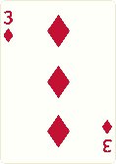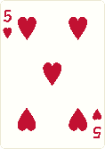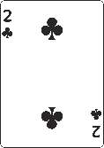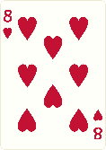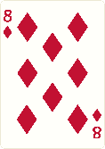

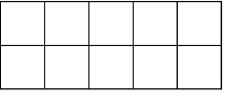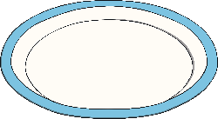

## Bonds to 10

Number bonds to 10 describe two numbers that together make 10. For example, 5 and 5 or 9 and 1.

Baby Bear has been collecting some flowers. He has put them in some ten-frames. Talk about how many more flowers Baby Bear needs to put on each ten-frame to make 10.

There are many ways to share 10 items into two sets. Talk about how the grapes have been shared on these two plates. Can you think of some other ways the grapes could be shared between the two plates?

Sing the song ’10 Green Bottles’. After each verse, how many bottles are on the wall and how many are on the ground?

## Comparing Numbers to 10

When comparing one quantity to another, it can be:

**more than fewer than the same as**

Talk about these nests of eggs. Which nest has the most eggs? Which nest has the fewest eggs? Can you find two nests that have the same number of eggs?

Remove the picture cards from a pack of cards. With a grown-up, turn over two cards. Compare the numbers and play a game of ‘snap’ by finding two cards that show the same number. Look at the cards on this page too. Talk about and compare the numbers you can see.

## 9 and 10

**9 10**

**nine ten**

Talk about which pictures represent the number 9 and which pictures represent the number 10.

Show me 10 fingers. Now, show me 9 fingers. Can you show me 9 fingers in a different way?

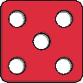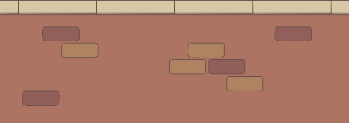

### Maths Talk and Learn: Supporting White Rose Maths Building 9 and 10

### Challenge Yourself:

* Go on a treasure hunt around your house and collect some small toys in an empty egg box with 10 spaces. Pause after you’ve put each toy in your egg box. How many items have   
  you found? How many more   
  do you need to make 10?

### Challenge Yourself:

* Use some building bricks to build towers. Place all of the bricks of the same colour into a tower.
* Which tower has the most bricks? Which has the fewest? Can you find two towers that have the same number of bricks?
* Can you place the towers in order? Start with the tower with   
  the fewest bricks and end with the tower with the most bricks.

### Challenge Yourself:

* Write the numbers 1 to 10 on pieces of paper (one number on each piece of paper). Can you place them in order from 1 to 10?
* Ask a grown-up to hide one of the cards.   
  Can you work out which number is missing?

## Pattern

A repeating pattern is a sequence or order of colours, shapes, objects, numbers, letters or actions. For example, circle, square, circle, square, circle, square would be a repeating pattern. So would, smile, frown, smile, frown, smile, frown.

A simple repeating pattern usually has two things that alternate and repeat, such as red, blue, red, blue, red, blue.

Repeating patterns can be more complex to include more objects and different types of repetition. For example, red, blue, blue, red, blue, blue, red, blue, blue.

Talk about this repeating pattern. What do you think would come next in the pattern? Why?

This pattern also uses green and purple buttons. How are the patterns similar? How are they different?

## 3D Shape

Have a look at these 3D shapes. How can you describe them? How are the shapes similar? How are they different?

**sphere cube cone cuboid pyramid cylinder**

Look at the pictures below and talk about what shapes you can see. What are the similarities and differences between them?

Go on a 3D shape hunt around your house. What 3D shapes can you find? Can you find some cuboids of different sizes? How do you know that they are cuboids? Sort the items into groups. How did you sort them? Could you sort them in a different way?

Talk about the 3D shapes Baby Bear has found. Can you work out how Baby Bear has sorted them?

### Maths Talk and Learn: Supporting White Rose Maths Building 9 and 10

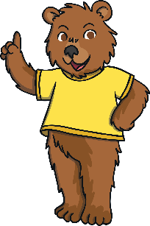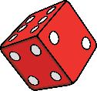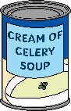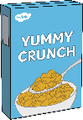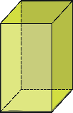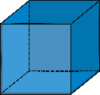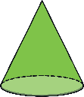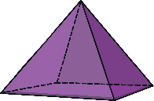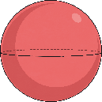

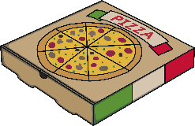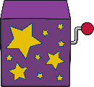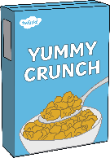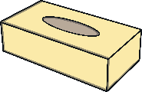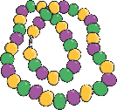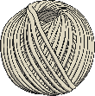

### Challenge Yourself:

* Use some coloured buttons, beads, coins or paper shapes to make a repeating pattern. What different patterns can you make using just two different colours/items?

### Challenge Yourself:

* Investigate some 3D shapes – you could use building bricks or items you found on your 3D shape hunt. Explore to see which shapes roll, which shapes slide and which shapes can be used to stack together into a tower.
* Use some building bricks to build a model. Talk about the shapes you use. Are some shapes better for different parts of your model? Why?