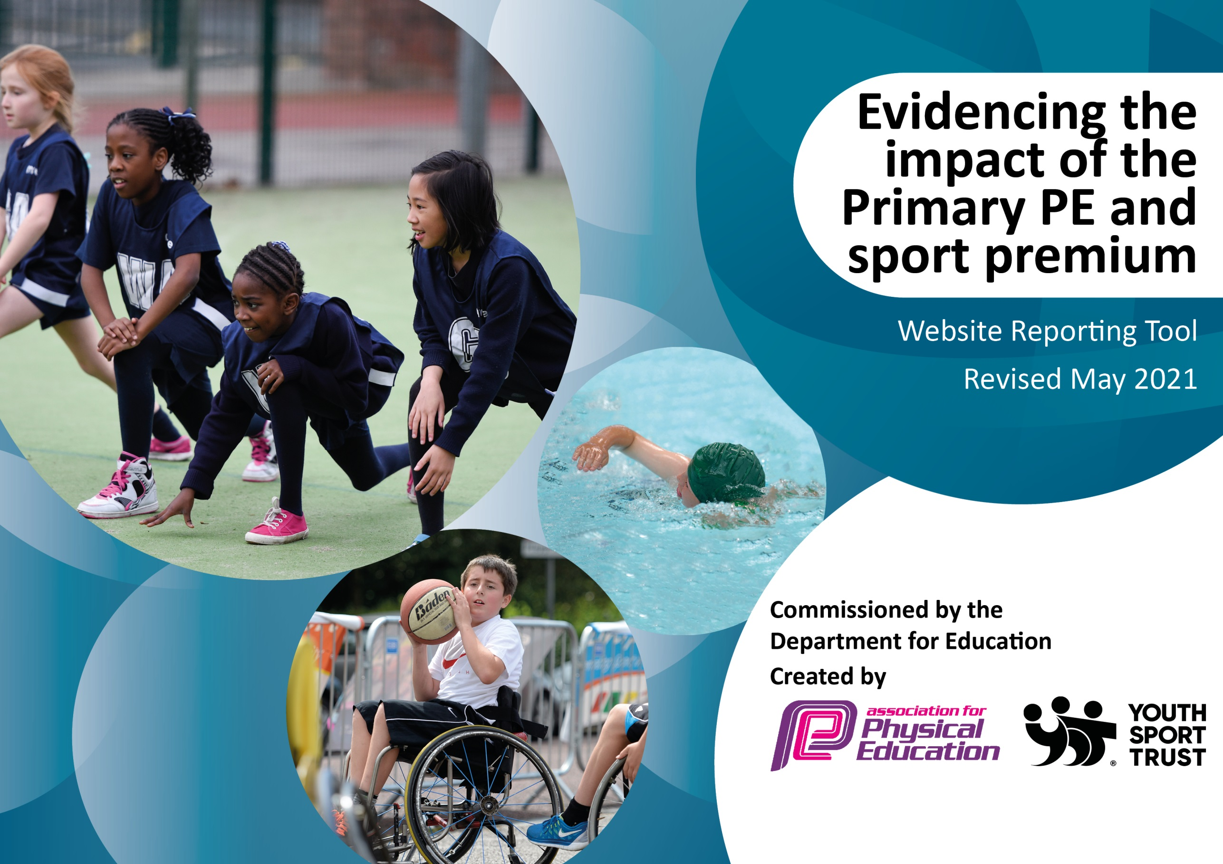

It is important that your grant is used effectively and based on school need. The Education Inspection Framework (Ofsted 2019 p64) makes clear there will be a focus on ‘whether leaders and those responsible for governors all understand their respective roles and perform these in a way that enhances the effectiveness of the school’.

Under the Quality of Education criteria (p41) inspectors consider the extent to which schools can articulate their curriculum (INTENT), construct their curriculum (IMPLEMENTATION) and demonstrate the outcomes which result (IMPACT).

To assist schools with common transferable language this template has been developed to utilise the same three headings which should make your plans easily transferable between working documents.

Schools must use the funding to make additional and sustainable improvements to the quality of Physical Education, School Sport and Physical Activity (PESSPA) they offer. This means that you should use the Primary PE and sport premium to:

- Develop or add to the PESSPA activities that your school already offer
- Build capacity and capability within the school to ensure that improvements made now will benefit pupils joining the school in future years
- The Primary PE and sport premium should not be used to fund capital spend projects; the school’s budget should fund these.
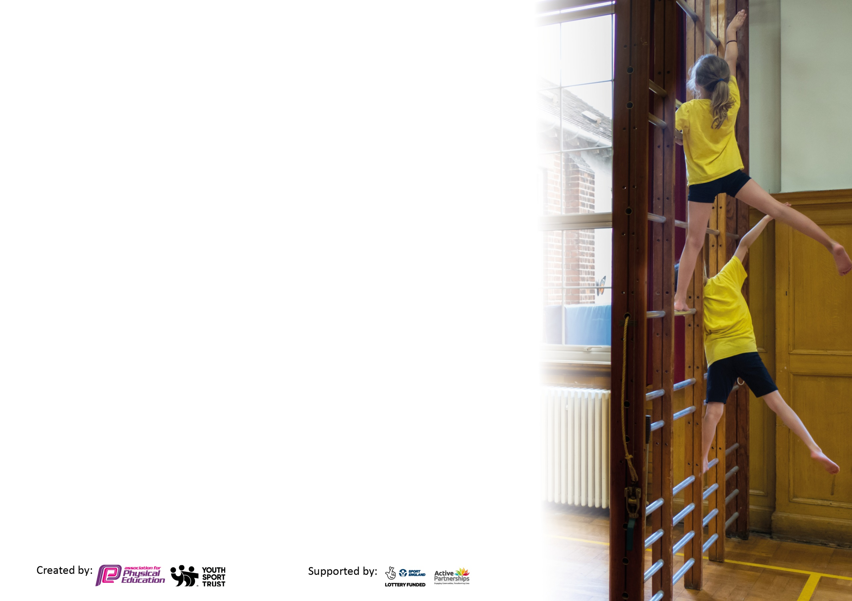
Please visit gov.uk for the revised DfE guidance including the 5 key indicators across which schools should demonstrate an improvement. This document will help you to review your provision and to report your spend. DfE encourages schools to use this template as an effective way of meeting the reporting requirements of the Primary PE and sport premium.

We recommend you start by reflecting on the impact of current provision and reviewing the previous spend.

Schools are required to publish details of how they spend this funding, including any under-spend from 2019/2020, as well as on the impact it has on pupils’ PE and sport participation and attainment by the end of the summer term or by 31st July 2021 at the latest.

We recommend regularly updating the table and publishing it on your website throughout the year. This evidences your ongoing self-evaluation of how you are using the funding to secure maximum, sustainable impact. Final copy must be posted on your website by the end of the academic year and no later than the 31st July 2021. To see an example of how to complete the table please click HERE.

Please note: Although there has been considerable disruption in 2020 it is important that you publish details on your website of how you spend the funding - this is a legal requirement.
Support for review and reflection - considering the 5 key indicators from DfE, what development needs are a priority for your setting and your pupils now and why? Use the space below to reflect on previous spend and key achievements and areas for development.

N.B. In this section you should refer to any adjustments you might have made due to Covid-19 and how these will influence further improvement.
Key achievements to date until November 2022: | Areas for further improvement and baseline evidence of need:
- Range of sports clubs for children Multi-sports (Years 1 and 2), Gymnastics (Years 1 and 2), Football (Years 3 and 4), Gymnastics (Years 5 and 6), Football (Years 5 and 6)  - Empower Squash Foundation sessions for 12 year 5 and 6 girls – squash, life skills and healthy meal weekly.  - Swimming sessions for year 6 children  - Get Set for PE scheme used for planning/progressions  - PE Road map developed to show pathway for progress for children  - Progression documents produced for key areas of PE  - Resources for all areas of PE improved.  - Increased number of children competing in inter school competitions – athletics, football, squash.  - Teachers’ understanding of PE curriculum has developed through use of the Get Set 4 PE website  - Links with local sports clubs are developing – squash, football, martial arts etc.  - School values are more closely aligned with the Get Set 4 PE values. | - To ensure Lillington are taking part in competitive sports and that all children have the opportunity to take part  - To develop young leaders across lunchtime  - Enter more competitions with Central Warwickshire Sports Partnership  - Develop the range of activities to reach the 30 minutes per day target  - Increase the number of children participating in internal sports competitions  - Offer staff more training opportunities  - Develop the range of extra-curricular sports and clubs that are on offer  - Develop swimming provision for key stage 2 classes.  - Increase opportunities for children to lead during PE and lunch activities  - Enhance the opportunities for the less active  - Develop the competition element at the end of each sequence of lessons

Did you carry forward an underspend from 2021-22 academic year into the current academic year? NO * Delete as applicable
Total amount carried forward from 2021/22 £0
+ Total amount for this academic year 2022/23 £18,160
= Total to be spent by 31st July 2023 £18,160
Meeting national curriculum requirements for swimming and water safety.

N.B Complete this section to your best ability. For example you might have practised safe self-rescue techniques on dry land which you can transfer to the pool when school swimming restarts.
Due to exceptional circumstances priority should be given to ensuring that pupils can perform safe self rescue even
if they do not fully meet the first two requirements of the NC programme of study.
What percentage of your current Year 6 cohort swim competently, confidently and proficiently over a distance of at least 25 metres?  N.B. Even though your pupils may swim in another year please report on their attainment on leaving primary school at the end of the summer term 2021.  Please see note above. | 25/45  56%
What percentage of your current Year 6 cohort use a range of strokes effectively [for example, front crawl, backstroke and breaststroke]?  Please see note above. | 25/45  56%
What percentage of your current Year 6 cohort perform safe self-rescue in different water-based situations? | 25/45  56%
Schools can choose to use the Primary PE and sport premium to provide additional provision for swimming but this must be for activity over and above the national curriculum requirements. Have you used it in this way? | No

Action Plan and Budget Tracking
Capture your intended annual spend against the 5 key indicators. Clarify the success criteria and evidence of impact that you intend to measure to evaluate for pupils today and for the future.

Academic Year: 2022/23 | Total fund allocated: | Date Updated: 24.11.22
Key indicator 1: The engagement of all pupils in regular physical activity – Chief Medical Officers guidelines recommend that primary school pupils undertake at least 30 minutes of physical activity a day in school |  |  |  | Percentage of total allocation:
 |  |  |  | 55%
Intent | Implementation |  | Impact
Your school focus should be clear - what you want the pupils to know and be able to do? What do they need to learn and consolidate through practice? | Make sure your actions to achieve are linked to your intentions: | Funding allocated:  £9,300 CVLife  £700 | Evidence of impact: what do pupils now know and what can they now do? What has changed?: | Sustainability and suggested next steps:
- Pay for a lunchtime play leader  - All pupils to receive 2 hours taught PE a week  - All children to attend at least one club.  - Targeted Year 5/6 non-swimmers to participate in booster lessons  - All pupils to participate in an intra- competition every half term (In PE sessions)  - All pupils to participate in half-termly whole school intra competitions.  - Enhance activity at lunch and break times.  - Introduce personal challenges  - Ensure 15 minute breaktimes are active | - Ensure CV Life staff member leads sports activities during lunch hour.  - Staff to incorporate at least 2 hours of PE into weekly timetable  - Timetable of after school clubs throughout the year  - Assessments during swimming sessions to identify children  - Competition week incorporated into half termly PE schedule  - Half-termly whole school competition  - Sports leaders (children) to facilitate sports activities during break times  - Identify 6 physical challenges for children to work on throughout the year.  - Range of resources for active break times | - CVLife  - CVLife  - CVLife  - £500  - CVLife  - CVLife  - CVLife  - CVLife  - £200 | - Children playing range of sports during lunch hour.  - 1 hour taught by CVLife coach and 1 hour by teacher  - Increased number of children attending clubs  - Children not completing 25m given some funding support  - Not achieved – plans in place for next year  - Not achieved  - Increased range of sports – football, dodgeball, skipping, netball, rounders and tennis.  - Personal challenges in some classes as part of fitness sessions.  - Range of activities for children | - Continue link with CVLife.  - Ensure sports coaches and teachers are all working towards the 30mins of activity.  - Use the school council/Lillington Leaders to identify sports that the children would like to take part in  - Develop the personal challenges to ensure they are recorded.  - Develop lunch and playtimes – plan to use an online resource is in place.
Key indicator 2: The profile of PESSPA being raised across the school as a tool for whole school improvement |  |  |  | Percentage of total allocation:
 |  |  |  | 6%
Intent | Implementation |  | Impact
Your school focus should be clear what you want the pupils to know and be able to do and about  what they need to learn and to  consolidate through practice: | Make sure your actions to achieve are linked to your intentions: | Funding allocated:  £780 CVLife  £220 | Evidence of impact: what do pupils now know and what can they now do? What has changed? | Sustainability and suggested next steps:
- PE objectives link to school learning behaviours  - Display values and behaviour expect  - Raise profile of PE and school sport in the community  - Celebrate participation through certificates.  - Ensure that Leaders are clearly recognised.  - House competitions  - Class/year competitions  - Sponsored events  - Display awards and trophies prominently  - Develop links with external sports clubs | - Emphasise school values in PE lessons/sports clubs  - PE notice board in central location  - Use social media, newsletter and website to report on sports  - Design and print certificates for different activities  - Buy caps/t-shirts for sports leaders  - Schedule competitions, buy trophies and bibs for kits  - Schedule  - Liaise with sponsor/charity coordinator  - Buy trophy cabinet and trophies  - Highlight links with local sports clubs on website, newsletter etc. | - CVLife  - £10  - N/A  - £10  - £50  - £50  - CVLife  - N/A  - £100  - N/A | - All Get Set 4 PE sessions have a link to learning behaviours  - Need to be shared explicitly  - Sports put in newsletter and Facebook more frequently  - Certificates for children when completing some activities.  - Sports leaders have badges and roles to play in events  - Sports day was an inert house competition – more planned for next year.  - Not achieved  - Not achieved  - Developing links but more needed | - Ensure all staff are making explicit links between the Get Set 4 PE values and school values.  - Develop the use of the newsletter and the school’s Facebook page to showcase sports weekly.  - Develop the system for house competitions – one per half term organised by the sports leaders.  - Ensure sports display board is updated regularly so children can see what’s happening.

Key indicator 3: Increased confidence, knowledge and skills of all staff in teaching PE and sport |  |  |  | Percentage of total allocation:
 |  |  |  | 12%
Intent | Implementation |  | Impact
Your school focus should be clear | Make sure your actions to | Funding | Evidence of impact: what do | Sustainability and suggested
what you want the pupils to know | achieve are linked to your | Allocated: | pupils now know and what | next steps:
and be able to do and about | intentions: | £2,000 CVLife | can they now do? What has
what they need to learn and to |  | £200 | changed?:
consolidate through practice:
- Enhance the knowledge, confidence and skills of staff to ensure the  Quality of PE sessions are at least ‘good’.  - PE coordinator to give clear guidance on what is to be taught.  - PE Coach to help improve confidence and expertise of staff.  - Improve knowledge of staff in more sports/ activities  - After school sport and activity clubs have good quality equipment | - Subscribe to Get Set for PE, share progressions, PDM time to identify qualities of a ‘good’ PE lesson  - PDM time to share long term plan and skills  - PE coach works alongside teachers to develop staff  - Training in different skills, progressions and games  - Identify equipment needed for different sports/activity groups | - CVLife  - N/A  - CVLife  - N/A  - £200 | - Better quality PE sessions taught. Lesson plans show range of support for all learners.  - School’s curriculum clear  - CVlife coach supported teachers with teaching.  - Not achieved  - Bigger range and better quality sports clubs. | - Develop use of PDMs (staff meetings) to share good practice and show where the Get Set 4 PE resource scan be used.  - Ensure the CVLife coaches are working alongside teachers and sharing good practice – how can we support different groups of children?

Key indicator 4: Broader experience of a range of sports and activities offered to all pupils |  |  |  | Percentage of total allocation:
 |  |  |  | 2%
Intent | Implementation |  | Impact
Your school focus should be clear | Make sure your actions to | Funding | Evidence of impact: what do | Sustainability and suggested
what you want the pupils to know | achieve are linked to your | allocated: | pupils now know and what | next steps:
and be able to do and about | intentions: | £400 | can they now do? What has
what they need to learn and to |  |  | changed?:
consolidate through practice:
- Curriculum maps to ensure coverage of a range of sporting activities.  - Access Empower Squash Foundation  - Children have taster sessions in a range of sports and activities (Inspirational workshops)  - Children are aware of professional/amateur competitions that take pace i.e Olympics, World Cups in a range of different sports. | - Complete curriculum maps – ensure all sports are resourced correctly  - Liaise with Leamington Tennis and Squash Club  - Liaise with local, inspirational sportspeople/clubs  - Teachers share sporting occasions with their classes | - N/A  - £200  - £200  - N/A | - Clear curriculum map to show all areas to be covered.  - Empower Squash accessed throughout the year.  - Not achieved  - Major sporting events shared with the children – discussed during Newsround events and PE sessions. | - Ensure curriculum map is followed by all staff.  - Ensure all resources are available for the curriculum.  - Ensure that follow up sessions are available or signposted after children try different activities.

Key indicator 5: Increased participation in competitive sport |  |  |  | Percentage of total allocation:
 |  |  |  | 26%
Intent | Implementation |  | Impact
Your school focus should be clear | Make sure your actions to | Funding | Evidence of impact: what do | Sustainability and suggested
what you want the pupils to know | achieve are linked to your | allocated: | pupils now know and what | next steps:
and be able to do and about | intentions: | CVLife £4,010 | can they now do? What has
what they need to learn and to |  | £550 | changed?:
consolidate through practice:
- All pupils to participate in Level 1 (intra)competitions throughout the year.  - Increased participation at Level 1 and Level 2 competitions  - Pupils to develop their sportsmanship, focusing on our school games values (respect, resilience, responsibility, reflection)  - PE Lead to develop the confidence of sports leaders and playground leaders and provide greater opportunities for students to lead, manage and officiate  - Enter local cluster, town, county and national competitions | - Join Central Warwickshire School Sports Partnership to track and monitor sports  - Purchase entry to level 1 and 2 competitions provided by CWSSP  - Regular intra school competitions (trophies, kits etc)  - Pay for leaders to be trained and then run competitions at play and lunch times  - Identify competitions that the children can enter | - CVLife  - £400  - CVLife  - N/A  - £150 | - All children competed in sports day so  - Increased number of children competed in sports competitions – athletics, football, squash etc.  - Sports leader (sports captains) had a greater role than in previous years.  - Not achieved – plans in place for next year. | - Ensure the different events are timetabled and parents/carers are aware so they can attend.  - Develop links with local schools to ensure there are more opportunities for competition.  - Re-enter the CWSSP and ensure designated member of staff supports with the organisation of events.

Signed off by
Head Teacher: | Victoria Wallace
Date: | 29.7.23
Subject Leader: | Mat Holt
Date: | 28.7.23
Governor: | Tricia Coopey
Date: | 29.7.23

