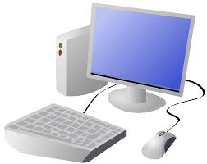
COMPUTING: PROGRAMMING- Sensing in Physical Computing
KNOWLEDGE ORGANISER
Y6

Overview |  |  |  | Programming Blocks
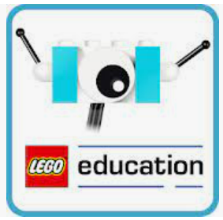  Sensing in Physical Computing  --Lego WeDo 2.0 is an App which enables Lego models to be programmed in order to create movements using robotics. This includes sensors which sense when an action is performed on the Lego model. The action will result in a movement or sound.  -We use algorithms (a set of instructions to perform a task) which we can plan, model and test, in order to create accurate and imaginative robotic actions.  - Input- The data which is entered into a computer or device.  Output Device- The device which receives data from a computer or device.  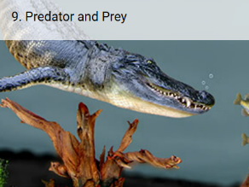 |  |  |  | -Output: Motor Blocks:  Motor This Way Block  Sets the motor to turn the axle in the direction shown.  Motor That Way Block  Sets the motor to turn the axle in the direction shown.  Motor Power Block  Sets the motor power to the desired speed and starts the motor.  Motor On For Block  Starts the motor for a chosen amount of time.  Motor Off Block  Stops any movement of the motor.  -Flow Blocks:  Start Block  Must be used at the beginning of a program string. Press on it to make the program start.  Wait for  Use this to tell the program to wait for something to happen.  Repeat Block  Use this block to repeat actions. Blocks placed inside will be looped.  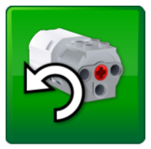  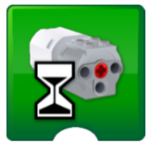  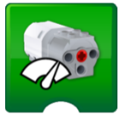  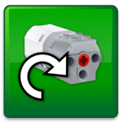  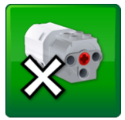
Projects Using Sensors
Volcano Alert:  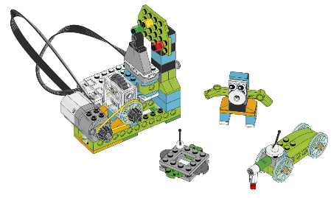  How do scientists use the different stages of volcanic activity to guide their scientific exploration?  You will learn to:  - Explore different ways scientists monitor volcanic activity.  - Create and program an alarm to indicate different stages of volcanic activity.  - Test your program to see how it indicates these at different stages. |  | Predator and Prey:  Choose from three solutions-  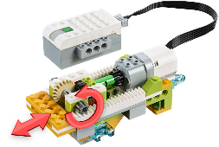  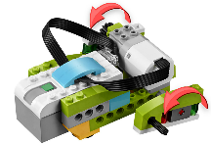  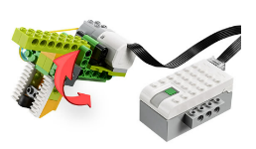  How can animals survive in their environment?  You will learn to:  - Explore the different strategies animals use to catch their prey or to escape from their predators.  - Create and program a predator or prey in order to explore the relationship between them.  - Present and document your animal model, explaining the relationship between two species and how that are adapted to survive.  Walk Grab Push
 |  |  |  | Inputs: | Test and Modify:
 |  |  |  | Sensors Change Input Blocks:  Tilt Up  Inputs the Tilt Sensor mode to “tilt up” to a block.  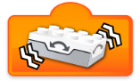  Shake  Inputs the Tilt Sensor mode to “Shake” to a block.  Numeric and Text Inputs:  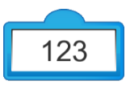  Number Input  Inputs a numeric value to a block.  Random Input  Inputs a random number to a block. | Try different programs to find out what else you can achieve.  For Volcano Alert, can you program your alarm to emit different signals for each of the three stages of the volcano? As an extra challenge, for each alter, move the drone, the animal, and the rover according to the signal.  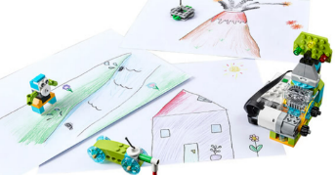  Remember to design, test, try and debug your program.
Important Vocabulary

Programming If…then…else…variable Random Direction Navigation Motion Sensor Input Output Motor Alarm Signal

